# TECTONISM AND LANDFORM EVOLUTION

Tectonism refers to all disturbances of endogenic origin that lead to formation of structural features on the earth’s surface.

The movements may be slow resulting into mountain building or may be rapid resulting into earth quakes.

Tectonism involves the processes of **diastrophism** ( earth movements) and **vulcanicity**.

# Diastrophism ( Earth movements )

These are endogenic movements which are associated with faulting, warping and folding.

**NB**: Diastraphism excludes vulcanism. Diastrophism forces may be orogenic or epeirogenic.

Epeirogenic forces act vertically i. e uplift and downwarping while orogenic forces act horizontally i.e tension, compression and the shear/tear forces.

# Origin of tectonism

Tectonism is due to great heat resulting from the pressure of the over lying rocks to the underlying rocks, friction between the moving plates, geochemical reaction and radio activity within the earth’s mantle. The heat melts the underlying rocks forming a molten substance that gives off convectional currents from the earth’s interior and these convectional currents move in different directions contributing to endogenic disturbances.

# FAULTING

This refers to the fracturing or breaking of the earth’s crust due to tectonic forces of compression, tension or shear that result into horizontal or vertical displacement of the crustal rocks.

A fault is a fracture or a crack along which some displacement of rocks has taken place. A fault is different from a joint in that a joint is a crack where no displacement has occurred.

**Types of faults**

These include; -

# 1. Normal faults

This results from tensional forces pulling the crustal blocks apart.

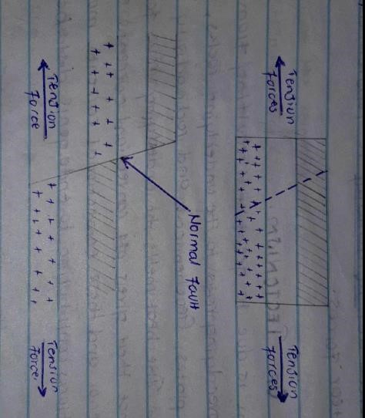

# 2. Reverse fault

This is due to compressional forces that push the blocks towards each other . One of the blocks overrides the other

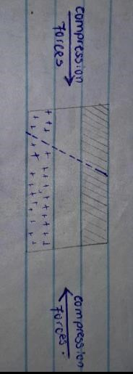

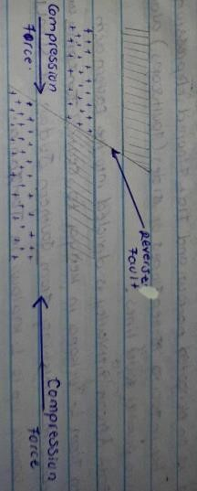

# 3. Tear fault /Shear fault

This is due to forces acting parallel to one another but in opposite directions. They lead to horizontal slipping or slidding of adjacent blocks of the crust against or over each other. Shearing may twist or tear up the crust.

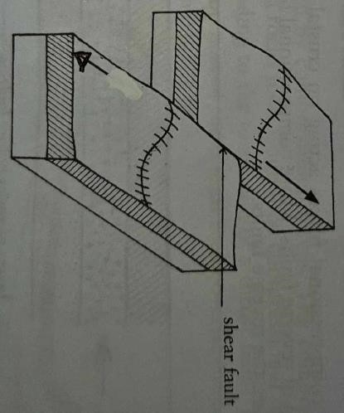

# LAND FORMS

Faulting has led to the formation of direct and indirect landforms in East Africa. **Direct landforms** include rift valley, rift valley lake basin, block mountains, escarpments, fault steps, tilt blocks etc. The **indirect** **landforms** include fault guided river valleys, fault line scarps etc

# 1. Rift valley

It is an elongated narrow and flat floored depression bordered by infacing steep slopes or sides ( faultscarps ) along more or less parallel fault lines.

The East African rift valley is divided into the Eastern arm stretching from L.

Turkana in Kenya to central Tanzania and the western arm stretching from Southern Sudan at Nimule to western Uganda up to L.Malawi in Tanzania. The rift valley is formed through the faulting process as explained under the following theories.

**(a) Tensional force theory/Greggory’s theory**

The tension force theory was advanced by Greggory and suggest that the crustal block is subjected to tension forces that pull apart the crust creating normal faults that divide the crustal block into three sections , middle block and two side/ adjacent blocks . The middle block subsides under its own weight to form a depression known as a rift valley.

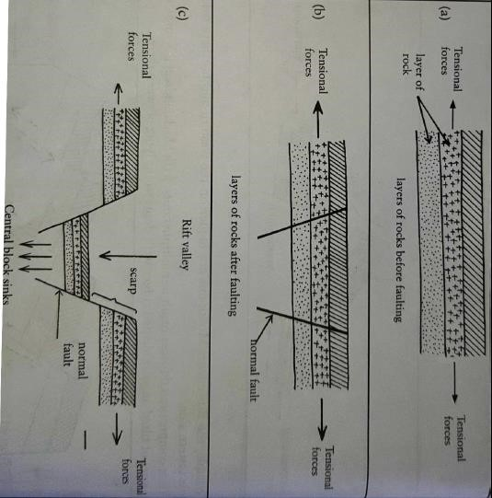

**NOTE:** This theory explains the formation of the Eastern arm. The tension force is validated by the Songwe fault scarps in the Rukwa rift which are recognized as normal faults.

Geological surveys in Kenya and Uganda have also revealed that the Rift faults are normal. The fault scarps also slant outwards from the rift valley floor.

# Weakness of the tension theory

The scarps are not uniform in height suggesting that it was not a similar mode for the formation that was experienced.

1. **The compression force/Wayland’s theory.**

Under compression, the crustal blocks are pushed towards each other involving reversed faults that divide the block into three parts; the central block and two adjacent blocks. As the compression force continues, the adjacent blocks are forced to over ride the stable central block leaving it at a lower level to form a depression known as a rift valley. The sharp edges of the upthrown block collapse due to erosion to expose the depression at the surface.

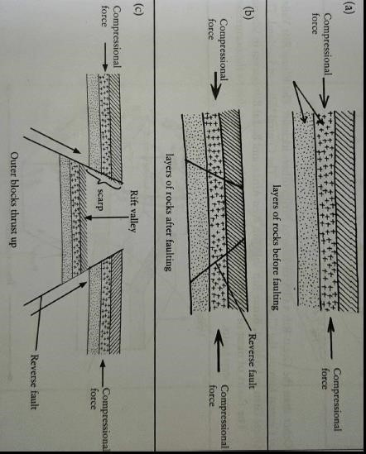

Waylands theory is supported by folded sediments at the floor of L. Albert . However the theory is disapproved on the ground that the deep bore holes sunk into the rift valley floor, are slanting and this proves that the rift valley was formed due to tensional force.

1. **Differential uplift theory ( Dixey’s theory)**

According to this theory, the crustal land mass was subjected to tension forces forming numerous normal faults that divided the crustal block into sections. The faulted landmass was then subjected to differential uplift. During the uplift the adjacent blocks rose faster than the middle blocks. The raised adjacent blocks formed the fault scarps whereas the middle block which remained at the lower level formed a rift valley.

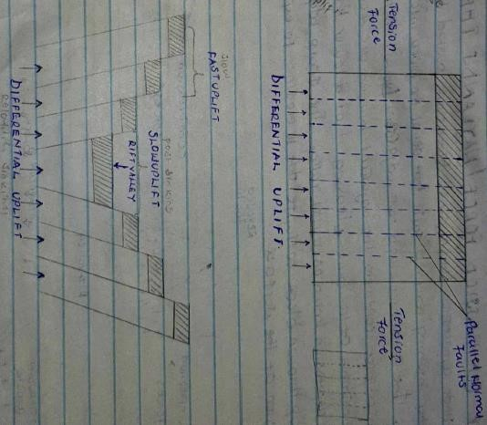

The presence of fault steps at the rift valley floor indicates the occurrence of differential uplift e.g at Kabete in Kenya . However, most parts of the rift valley lack fault steps this weakness the theory .

1. **Relative sinking theory**

# (e) Uparching theory ( Basin & swell)

According to this theory advanced by L.C King , a rift valley resulted from a powerfull uparching where Central Africa was subjected to about some Million years before present. Due to uparching , the crust bent upwards and cracked open due to tension at the sides and uparching in the centre ( were the cracking took place ). The crack widened partly due to further weathering and erosion to form the rift valley.

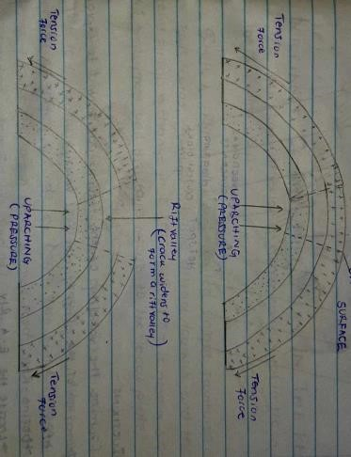

**Relevance:**

Rift valleys are relatively raised and have fault scarps illustrating the uplift. The occurrence of the central basin L.Victoria and Kyoga separate the rifts proves the occurrence of uparching creating the basins . However basins are found in smaller areas.

# (f) Plate tectonism theory/Girdlers theory

According to plate tectonism, the East African rift valley was formed as a result of crustal separation as in a manner of continental drift as explained under plate tectonism and sea floor spreading theories . The theory is supported by the widening of the East African rift valley at a rate of 2 cm per year.

# Questions

1. Examine the validity of the theories put forward to explain the formation of the East African rift valley.
2. Account for the formation of the East African rift valley.
3. Assess Greggories theory of rift valley formation.

# IMPORTANCE OF THE RIFT VALLEY IN THE REGION

The East African rift valley is economically vital in the region in the following ways;-

* The East African rift valley and its associated unique features such as fault scarps, fault lake basins attract tourists and this earns foreign exchange in the region. Tourism is also a source of employment and this earns income to the local people.
* The Rift valley floor is occupied by depressions filled up with water to form fault lakes such as Tanganyika , Albert, George which act as fishing grounds eg Dagaa fish from L.Tanganyika which is a source of human food , animal food, source of income to fishermen when fish is sold off.
* The rift valley floor is associated with mineral deposits some of them have so far been exploited e.g soda ash from L. Magadi used for manufacture of glasses, salt for human consumption etc. Other potential mineral deposits include oil in Albertine flats.
* The East African rift valley floor is covered by fertile soils which when given water support agriculture e.g Mubuku irrigation scheme.
* The rift valley floor has pasture , savannah grass land which supports pastoralism e.g Masai land.
* Rift valley areas are sites for power/H.E.P generation. Where the rift valley escarpment is crossed by a river , waterfalls are formed e.g Bugoye , Mobuku I & II. Kabalega falls on R. Nile , encourage production of H.E.P for domestic and industrial use.
* Within the rift valley there are lines of weaknesses, associated with volcanic features like the hot springs such as Kitagata. Such features encourage generation of geothermal power. Eg at Olkaria in Kenya providing power for industrial and domestic use.
* Wildlife conservation, the floor of the rift valley of East Africa experiences conditions that favour the growth of grass and scattered trees. Such vegetation has been utilized for wild game conservation e.g Rwenzori National Park in Uganda, Tsavo National park etc.
* Rift valley lakes provide water for human consumption, industrial use and for irrigation purposes .
* The flat floor of the rift valley is used for human settlement for example Kasese town.
* Beautiful sceneries of the rift valley provide sites for photography and filming which advertises Uganda and her resources.
* Rift valley lake basins such as Tanganyika, Albert are being used as transport routes for carrying goods and people e.g Albert connecting Uganda to Democratic Republic of Congo.
* The varied features in the rift valley are used for educational purposes.
* The rift valley escarpments on the wind ward sides receive heavy rainfall which supports forestry e.g Rwenzori forests.

# NEGATIVE

* Rift valley areas experience severe earthquakes which destroy lives, crop fields and infrastructure for example in Bundibugyo, western Uganda..
* The rift valley floor is in the rain shadow, experiencing hot and dry conditions which are not suitable for Agriculture and settlement.
* The rift valley and its escarpments hinder the construction of roads and railway networks resulting into remoteness of the rift valley areas.
* Salty water lakes in the rift valley provide hard water which is not suitable for domestic use.
* Rift valley areas are habitants for dangerous wild animals that are a threat to man and his animals e.g lions , wild cats etc.
* The steep slopes of the rift valley escarpments experience soil erosion leading to infertile soils that cannot support agriculture.
* Landslides occurrence due to steep nature of the rift valley escarpments and these destroy transport networks , crop fields and settlements.
* Low lying areas of the rift valley experience floods which are destructive in nature.

**Question**

Examine the importance of the East African rift valley to the region.

# Block mountain ( Horst)

A block mountain is an upland bordered by faults on one or more sides. It stands above the surrounding land as a result of being raised up by earth movements along the faults. It is formed due to faulting and uplifts brought about by tectonic movements of either tension , compression or differential displacement i.e uplift and subsisdence. Forces of block mountain formation include;-

# (a) Tension force theory

This involves the development of parallel normal faults that divide the crustal block into three sections two side blocks and one middle block ,due to tension forces. After faulting, the crustal block is subjected to relative sinking and in the process the adjacent blocks sink faster than the middle block. The middle block is relatively stable and remains standing up at a higher level forming a block mountain.

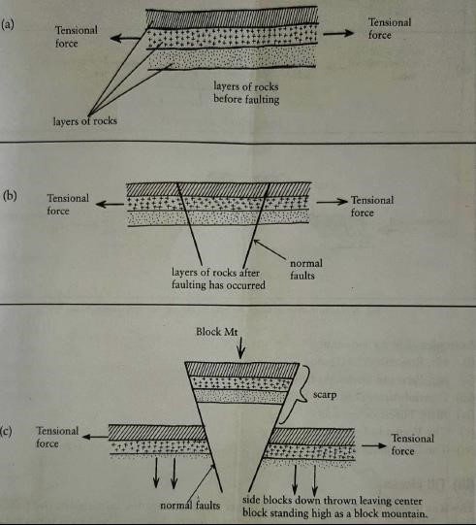

# (b) Compression force theory

It involves the pushing of the crustal blocks in the same direction towards each other. The reversed faults are formed that divide the crustal block into three section , the central and two adjacent blocks. The central block undergoes up thrust while the side blocks remain stable. The upthrown middle block forms a horst.

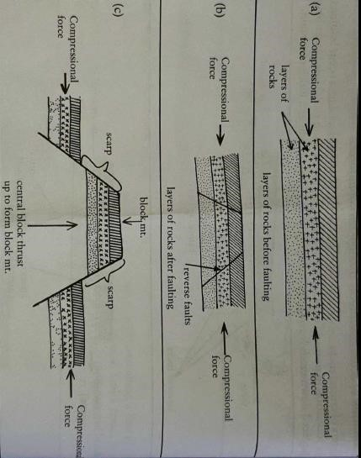

# (c) Differential uplift

The land is subjected to either tension or compression forces creating lines of weakness that divide the crustal block into numerous sections. The faulted block is then subjected to differential uplift and in the process the middle block is lifted faster than the side blocks to form a block mountain.

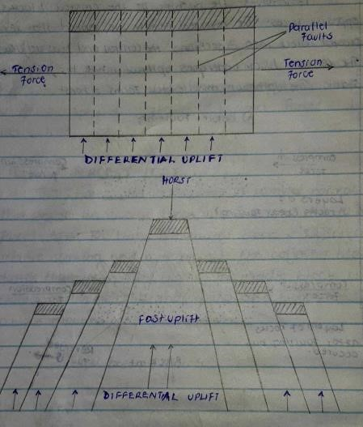

Examples of block mountains include;

Mt. Rwenzori in Uganda, Usambara, Ulunguru in Tanzania.

# Question

1.(a) Account for the formation of Mt. Rwenzori.

(b)Explain the importance of Mt. Rwenzori to the people living in the region.

# Rift valley lake basin/Fault lake basin(graben)

These are narrow, deep elongated depressions with a regular shape and steep sides formed at the rift valley floor. They are formed through the process of **secondary faulting** within the rift valley. The forces or theories for their formation include: -

# (i) Tension force theory

Heating by radioactivity and geochemical reactions results into convective currents. When convective currents reached the earth’s crust, they tended to diverge leading to tension forces that caused normal faulting, side blocks moved away from each other while the middle block sunk under its own weight to form the rift valley.

Continued convective currents resulted into **secondary faulting** and **secondary** **sinking** of the part of the rift valley floor to form a **secondary** depression referred to as a **fault lake basin**.

The depression ( secondary depression ) may get filled up with water from rivers, rain water or springs forming fault lakes eg Lake Albert filled up with water from R. Semuliki, Muzizi, Nkusi , Victoria Nile and also the rain water. For Lake Tanganyika, the depression was filled up by river Malagarasi.

Examples of fault lake basins include;- L.Tanganyika basin , Lake Albert basin, L. Turkana basin, L. George basin, L. Edward etc.

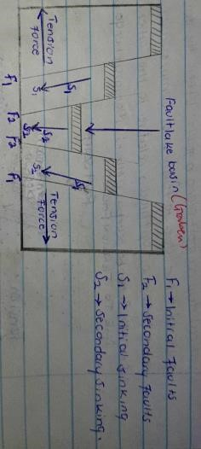

# (ii) The compression force theory

Under compression force theory, there was heating by radioactivity and geochemical reactions that resulted into convective currents. When the convective currents reached the earth’s crust, they tended to converge leading to reversed faulting. The side blocks tended to over ride the middle block which remained as a rift valley.

As convective currents continued, there was **secondary** faulting that resulted into the formation of a secondary depression or hollow commonly referred as a fault lake basin.

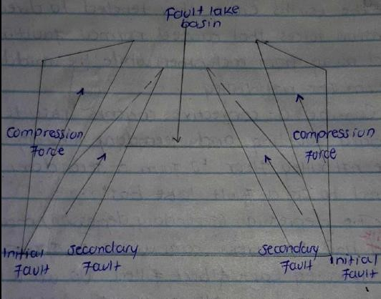

# 4. Fault scarps ( escarpments)

A fault scarp is a steep slope where the land falls from a higher level to a lower level.

Fault scarps are steep slopes along a rift valley caused by vertical displacement along a fault. Where the earth’s crust is fractured either due to tension or compression, one block is down thrown or up thrown relative to the other. Examples ; Butyaba scarps ( L.Albert ) , Manyara Chunya scarps , Mau escarpment in Kenya.

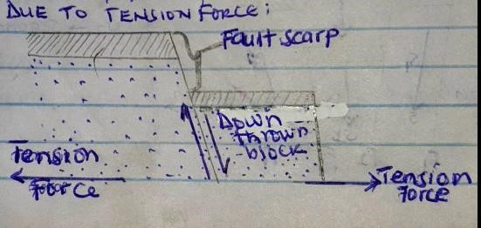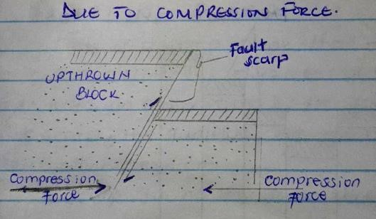

# 5. Tilt blocks

This is an upland with angular ridges and depressions formed by a series of tilted fault blocks. Tilt blocks are formed due to compressional forces that lead to formation of multiple reverse faults in the rock layers. Continued compressional forces lead to one side of the block being raised higher than the other forming a tilt landscape.

Examples are seen in North West of Aberdare ranges in Kenya.

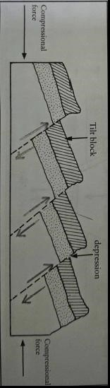

# 6. Fault steps

These are step like land scapes that occur at the edges of the rift valley. They are formed due to differential uplift of the land scape where the side fault blocks are lifted faster than the middle blocks.

Example can be seen at kedong in Kenya.

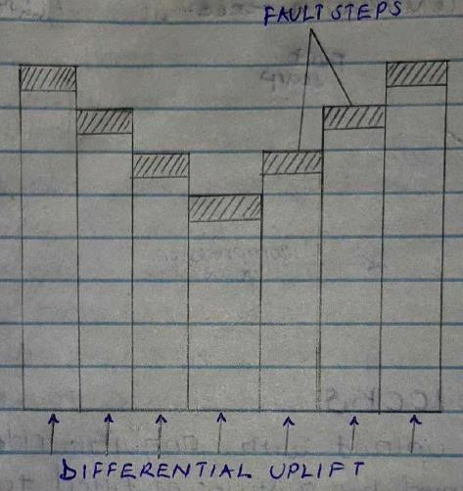

# 7. Fault guided valleys

These are long depressions or valleys formed when faulting shatters the rocks which are later subjected to weathering and erosion. The crushed rocks are easily removed by erosion leaving behind a fault guided valley. Rivers may flow along these valleys and are refered to as the fault guided rivers eg R. Aswa in North Uganda , Kerio valley in Kenya.

# 8. Faultline scarp

This is a steep slope that develops along an ancient faultine by differential erosion of hard and soft rocks on either side of the faults. Under a fault line scarp, the faultlines are not noticeable, they are destroyed by erosion.

A scarp facing the same direction as an original fault scarp is known as a normal faultline scarp or the consequent fault line scarp.

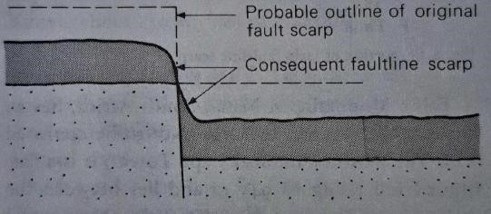

A scarp facing in the opposite direction to the original fault scarp is termed as reversed or obsequent fault line scarp.

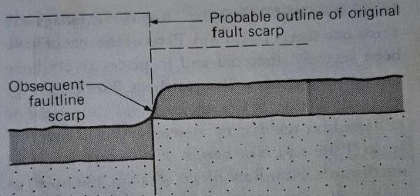

# Questions

1. Distinguish between a faultline scarps and fault guided valley.
2. Assess the contribution of fault guided valleys to man.

# 9. Water falls

These are sharp breaks along the river’s course where water falls from a higher level to a lower level at a high speed. Waterfalls are formed when the rivers bed is subjected to either tension or compression and one of the faulted blocks is down thrown leaving the other block at a higher level to form a faultscarp across the river valley. At this point, water falls from a fault scarp to a lowered surface forming a water fall e.g Kabalega and Karuma falls on R.Nile.

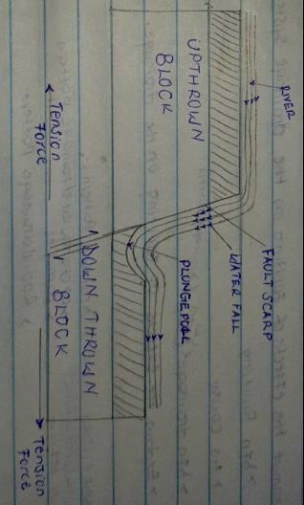

# 10. River offset

Tear faulting , a horizontal movement across a river will cause the river to be off set at a point it crosses the fault.

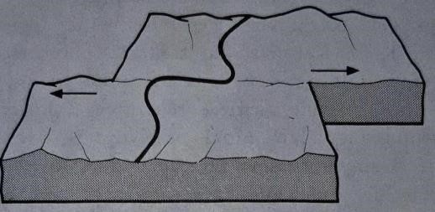

# Questions

1. Assess the effect of faulting on land form evolution in East Africa.
2. Examine the effects of faulting on the drainage system of East Africa.
3. Account for the land forms resulting from faulting process in East Africa.

**IMPORTANCE OF FAULTING**

Refer to block mountain, rift valley, rift valley lakes.

# WARPING

It is a tectonic process that involves distortion of the earth’s surface by uneven upward or downward movement leading to formation of plateau and basins. It is a slow process that involves slight movement and usually covers an extensive area.

The process is due to compressional forces and it originates from the earth’s interior due to radioactivity, geochemical reactions, friction between moving plates and pressure from the overlying rocks to underlying rocks which generate heat that melts underlying rocks to form a molten substance, this finally gives off the convective currents resulting into warping.

Warping resulted into the formation of the down warped lake basins like Lake Victoria and Kyoga. Down warped lake basins are characterized by having irregular shoreline , shallow, large depressions and being saucer shaped in appearance.

Down warped basins were formed when the central part of Uganda was down warped whereas the western and eastern parts experienced upwarping . This created a saucer shaped depression with irregular shore line in the centre. Rivers originally flowing in the west & east reversed their directions of flow and filled up the depressions forming lakes. Rivers that reversed direction include. R. Katonga and Kagera forming in Lake Victoria, Kafu formed Lake Kyoga.

